# Race Day Setup Map and Parts List

|  |  |  |  |  |  |  |  |
| --- | --- | --- | --- | --- | --- | --- | --- |
| **M1** | |  | **M2** | |  | **M4** | |
| 1 | Stand |  | 1 | Stand |  | 1 | Power cord |
| 1 | Rasberry pi bracket |  | 1 | Rasberry pi bracket |  | 1 | Rasberry pi / Monitor Combo |
| 1 | Set of 4 Screws |  | 1 | Set of 4 Screws |  | 1 | 3-way power block |
| 1 | Monitor Power cord |  | 1 | Monitor Power cord |  | 1 | extension cord |
| 1 | Monitor Cable |  | 1 | Monitor Cable |  | 1 | Camera |
| 1 | Network Cable |  | 1 | Network Cable |  | 1 | Keyboard |
| 1 | Rasberry pi |  | 1 | Rasberry pi |  | 1 | Mouse |
| 1 | Monitor |  | 1 | Monitor |  |  |  |
| 1 | 3-way power block |  | 1 | 3-way power block |  |  |  |
| 1 | long extension cord |  | 1 | long extension cord |  |  |  |
|  |  |  | 2 | Floor Cord Management |  |  |  |
| **M3** | |  | **Table** | |  |  |  |
| 1 | Monitor Power cord |  | 1 | Network Switch |  |  |  |
| 1 | Monitor Cable |  | 1 | Powerbar |  |  |  |
| 1 | PC |  | 1 | Speaker |  |  |  |
| 1 | Network Cable |  | 1 | Laptop |  |  |  |
| 1 | 3-way power block |  | 1 | AirCube |  |  |  |
| 1 | extension cord |  | 1 | Ubquitiy white device |  |  |  |
| 1 | Camera |  | 1 | Projector |  |  |  |

Raspberry Pi Connections used:

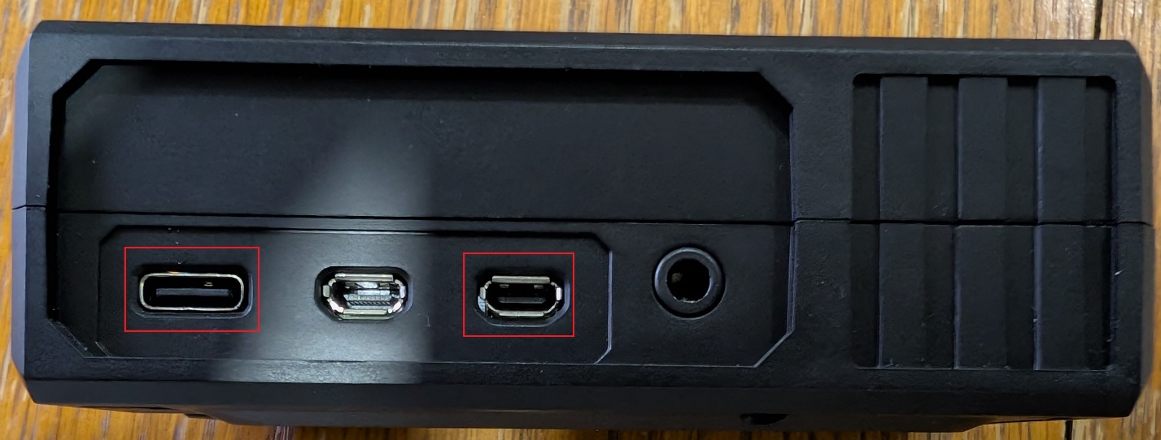

Timer Setup:

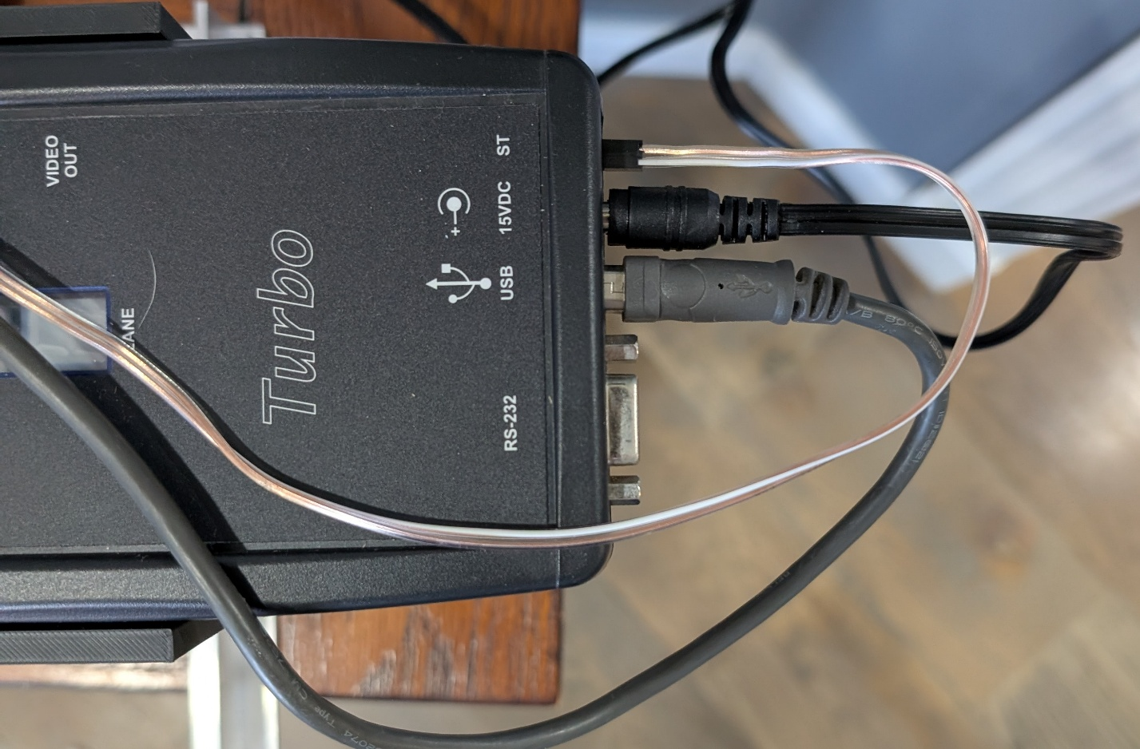

Monitor Setup:

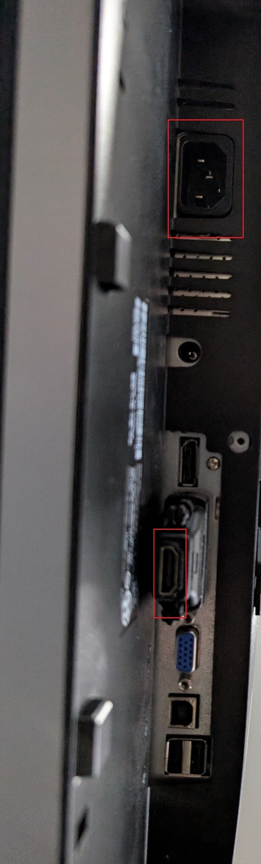

Monitor Setup:

